### A Shamrock Trinket Box for St. Patrick's Day

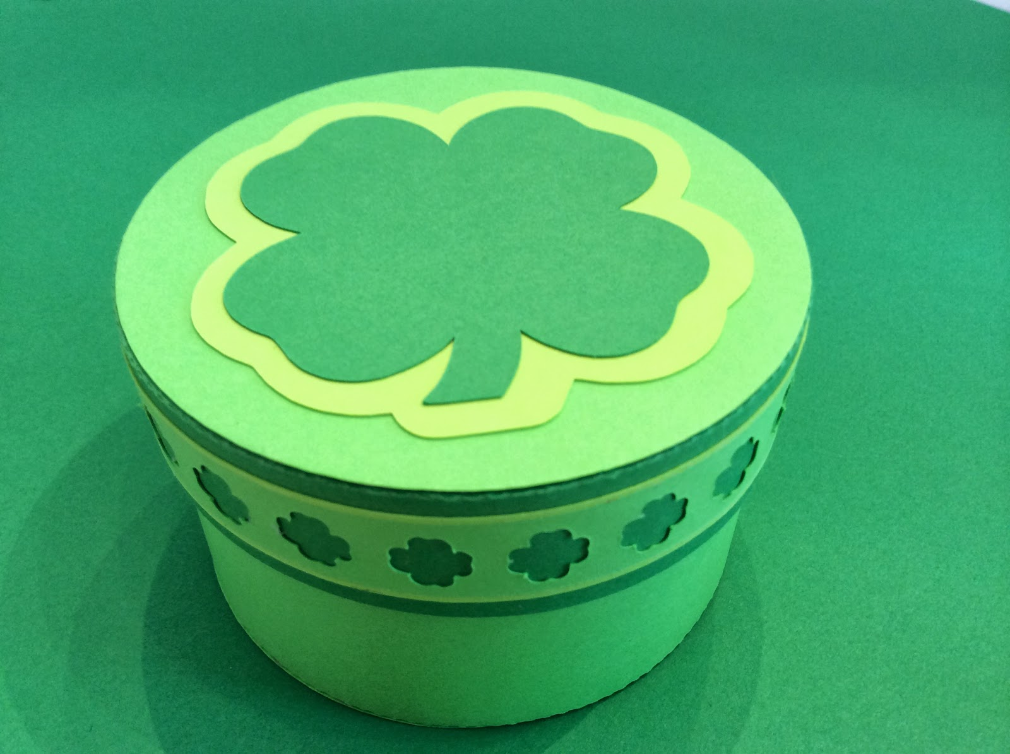

Shamrock Trinket Box

Today is St. Patrick's Day. I decided to make this pretty little trinket box to hold some chocolate treasure.

Happy St. Patrick's Day!